VOTING APP DEMO

Max Score: 50

**BACK TO ASSIGNMENT**

FIRST : Take the voting app presentation (PPT) and understand the landscape of the application.

1. go to root (cd /root/ ) . (both Master and Worker can perform this in their instances)

2. git clone https://github.com/ashishrpandey/example-voting-app

3. go to /root/example-voting-app/k8s-specifications

4. [root@ip-172-31-7-102 k8s-specifications]# **kubectl apply -f .**

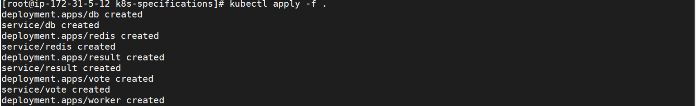

5. for voting and result pods, Observe that NodePort is assigned.

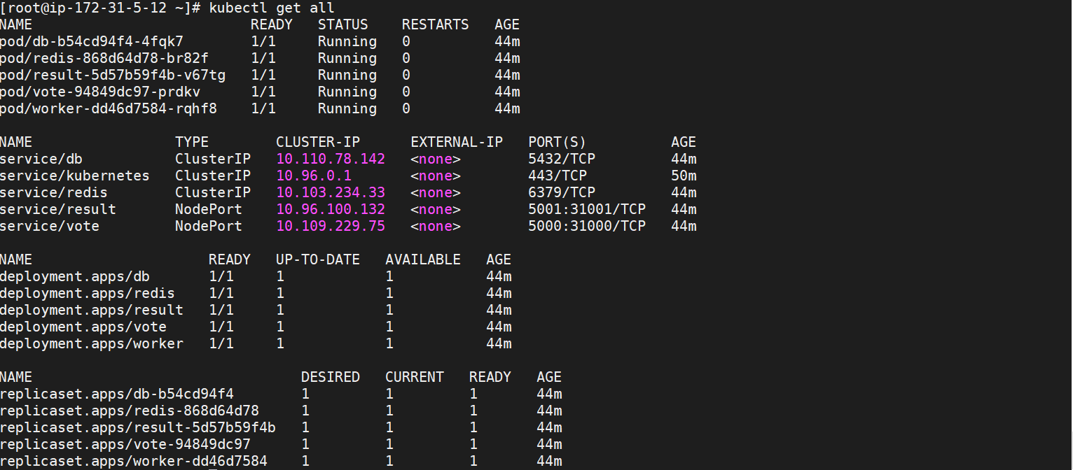

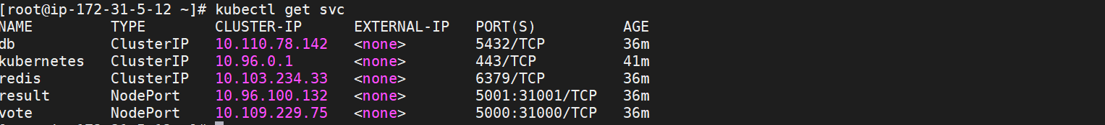

6. take your publicIP (your instance IP) : NodePort ► open 2 browsers , one for VOTING and one for Results.

7 try voting and see the results paralelly in results page.

8. Now try to delete the Pods one by one (first voting Pod, then worker pod, then db pod) and see what happens to the voting and result app after deleting.

First delete the voting pod , after deletion , successfully new pod created.

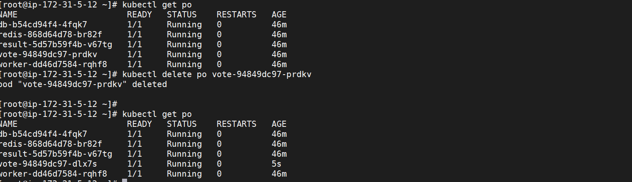

delete the worker pod , after deletion , successfully new pod created.

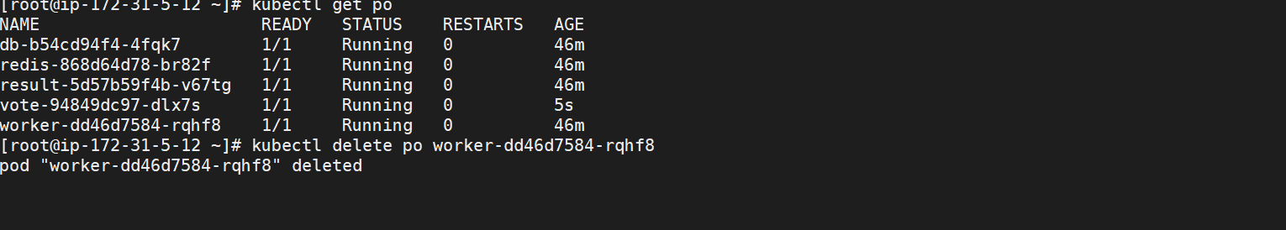

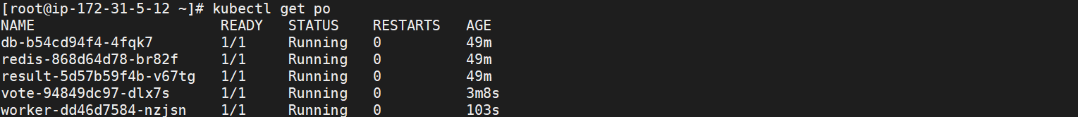

delete the db pod , after deletion , successfully new pod created.

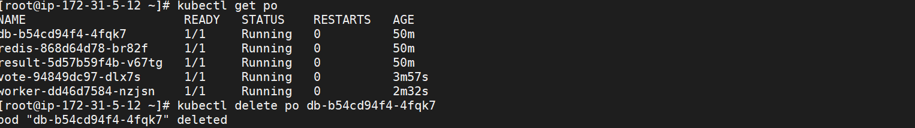

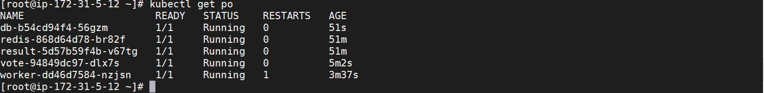

After deletion , the result-app browser has restarted .

Tried for vote using voting -app on GUI, it doesn’t updated on result-app.

Select the “CATS” on voting -app , result has not updated

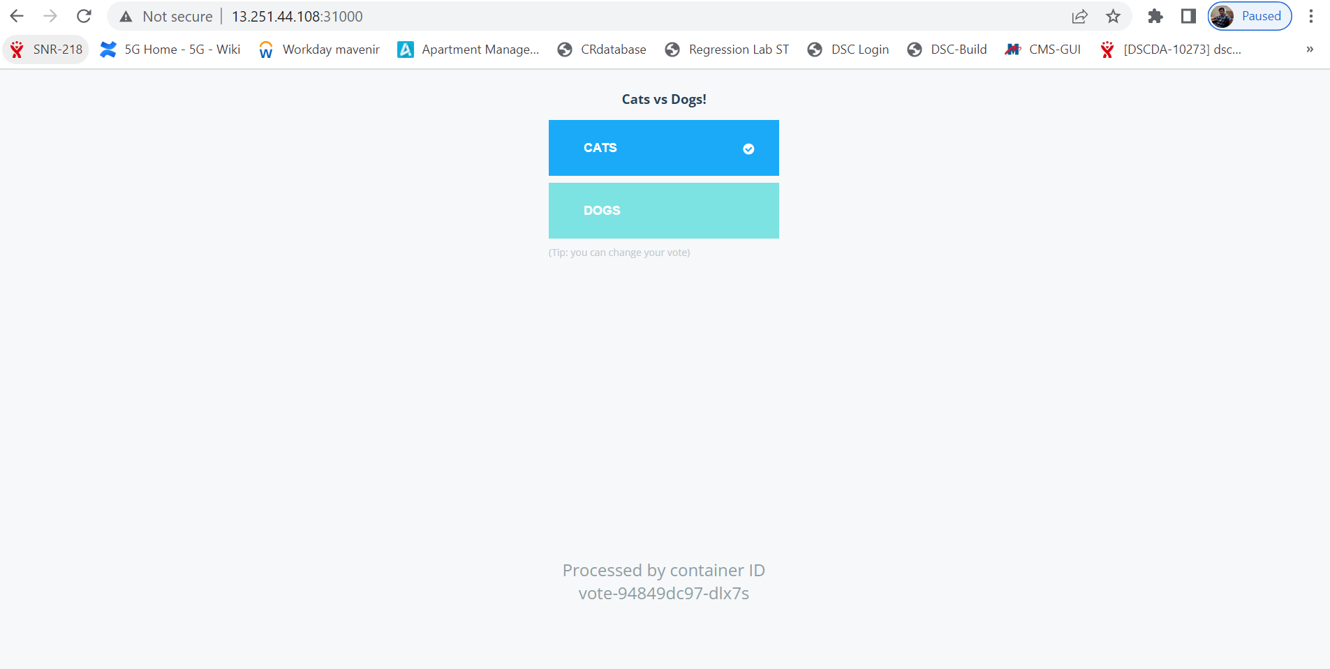

Similarly Select the “DOGS” on voting -app , result has not updated

what happens after db pod deletion

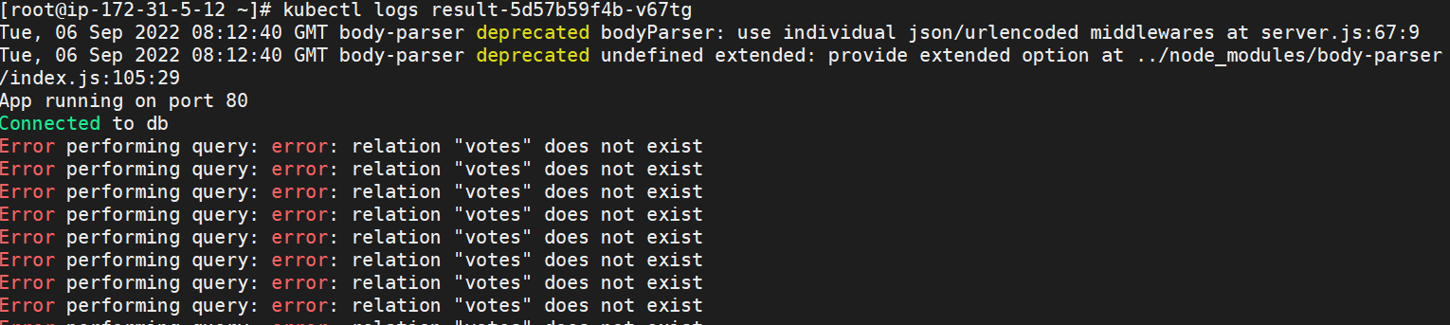

complete the assignment by making the result pod work. (if you delete db pod, results would not be captured. So repeat what we did in the class in order to make the result pod work.

Delete the result-app , after deletion new pod created.

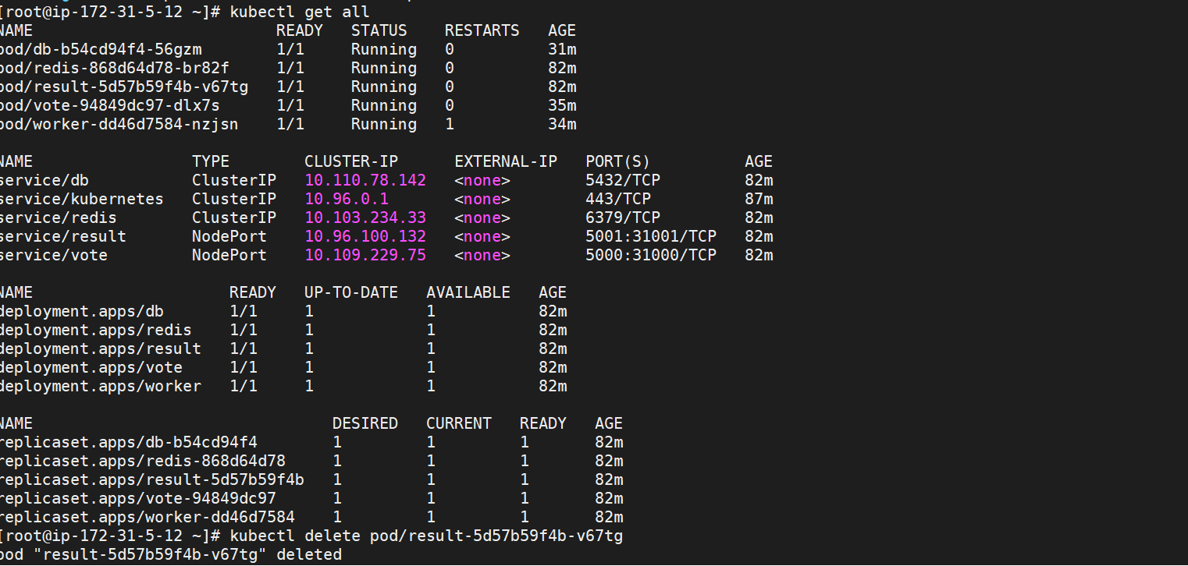

After deletion the result-pod , connection between db-pod and result-pod reestablished.

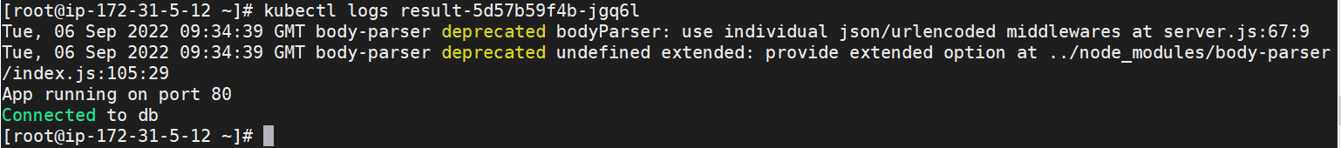

Using voting-app , select the vote using gui.

Choose the “CATS” using voting-app

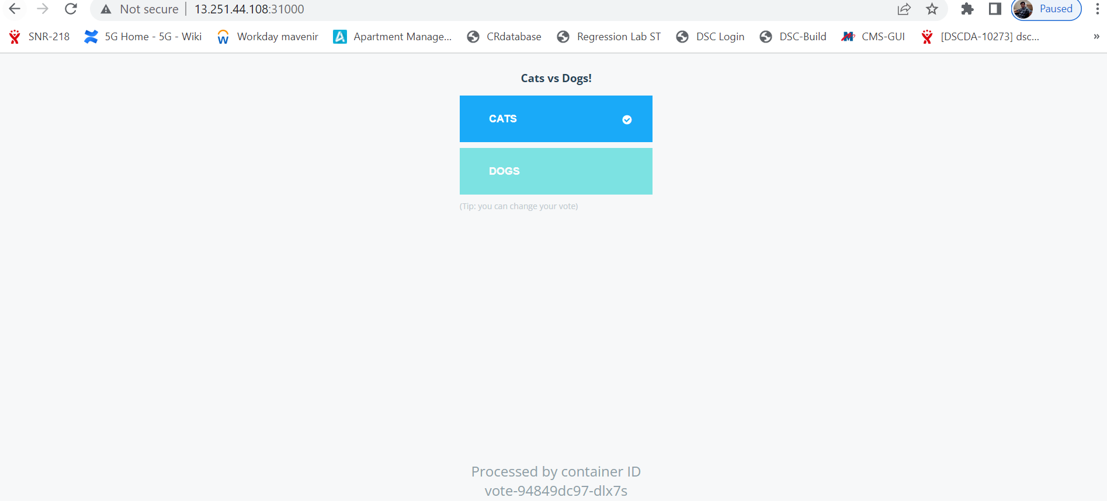

Result updated on result-app .

Choose the “DOGS” using voting-app

Result updated on result-app .

